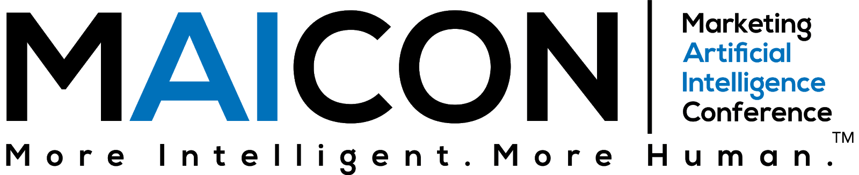

Dear <Insert Manager’s Name>,
I would like your approval to attend the Marketing Artificial Intelligence Conference (MAICON). Held by Marketing AI Institute, MAICON is designed to help marketing leaders truly understand AI, educate their teams, garner executive support, pilot priority AI use cases, and develop a near-term strategy for successfully scaling AI.
The conference is taking place July 26-28, 2023.
Now in its fourth year, MAICON attracts hundreds of professionals from all over the world.
Why is this conference worth the investment?
McKinsey Global Institute projects up to a $6 trillion impact of AI and other analytics on marketing and sales, and I’d like to see how I can help make that impact within our organization.
MAICON is a multiple-day, single-track event focused on the state of marketing AI including the major changes that have already happened in the past 12 months, and also what the future holds. Speakers are marketing professionals, business leaders, AI experts, practitioners, and analysts who can help me better understand and put this all into action.
Here are a few other benefits of attending:
- To network with a community of forward-thinking marketers
- To find AI-powered marketing technologies that could help our team do our jobs smarter
- To have access to the top resources, contacts, and AI solutions
- To learn from leading marketing practitioners who are piloting and scaling marketing AI solutions
- To stay ahead of our competitors by advancing our knowledge and capabilities in marketing AI
Following MAICON, I will share key takeaways and immediate action items that our team can use to develop a strategic approach to AI. I’ll bring back best practices, use cases that I see as opportunities for our organization, and new connections who can support us on this journey.
Below is an approximate cost of attending for your consideration.
Conference: $xxx (update to current ticket price)
Hotel: $xxx
Travel: $xxx
Total: $xxx
Thank you for your prompt consideration of this request. Prices increase on [date], so I’d like to register before that increase.
All the best,

