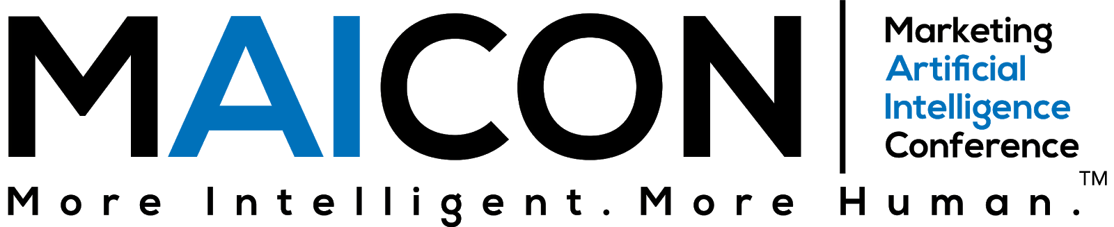

Dear <Insert Manager’s Name>,
I would like your approval to attend the Marketing Artificial Intelligence Conference (MAICON). Held by Marketing AI Institute, MAICON is designed to help marketing leaders truly understand AI, educate their teams, garner executive support, pilot priority AI use cases, and develop a near-term strategy for successfully scaling AI.
The conference is taking place Sept. 10-12, 2024.
Now in its fifth year, MAICON attracts business and marketing professionals from all over the world. Attendance was in the 300s range in the first three years of the event, 700 in 2023, and 1,500 are expected in 2024.
Why is this conference worth the investment?
McKinsey Global Institute projects up to a $6 trillion impact of AI and other analytics on marketing and sales, and I’d like to see how I can help make that impact within our organization.
MAICON is a multiple-day, multi-track event focused on the state of AI including the major changes that have already happened in the past 12 months impacting businesses and marketing, and also what the future holds. Speakers are marketing professionals, business leaders, AI experts, practitioners, and analysts who can help me better understand and put this all into action. We are at a critical time for our business to become AI emergent.
I am ready to:
- Build our competitive advantage by increasing our knowledge and capabilities in marketing AI
- Network with a community of forward-thinking marketers and business leaders
- Find AI-powered marketing technologies that could help our team do our jobs smarter, more efficiently, and more effectively to grow our business
- Have access to the top resources, contacts, and AI solutions
- Learn from leading marketing practitioners who are piloting and scaling marketing AI solutions.
Following MAICON, I will share key takeaways and immediate action items that our team can use to develop a strategic approach to AI. I’ll bring back best practices and use cases that I see as opportunities for our organization, frameworks to help us advance the right way, and new connections who can support us on this journey.
Below is an approximate cost of attending for your consideration.
Conference: $xxx (update to current ticket price)
Hotel: $xxx
Travel: $xxx
Total: $xxx
Thank you for your prompt consideration of this request. Prices increase on [date], so I’d like to register before that increase.
All the best,

